## Building a Multidimensional Cube for SQL Server Analysis Services

**Lab Time**: 60 minutes

**Lab Folder**: C:\Student\Modules\Cubes\Lab

**Lab Overview**: In this module you will work through the steps to create a multidimensional cube using Wingtip Sales database and the SQL Server Data Tools. This will give you hands-on experience working with fact tables, dimension tables, measure groups, measures and KPIs.

### Exercise 1: Adding a Support Table and Views to the Wingtip Sales Database

In this exercise you will launch the SQL Server Management Studio and use this utility to execute a pre-provided SQL script which will create a **SalesRegion** support table. You will execute a second SQL script to create four new views which will be utilized by the multidimensional cube that you will build in the next exercise that follows this exercise.

1. Login to the Student VM using the login **WINGTIP\Administrator** and the appropriate password.
2. Launch the SQL Server Management Studio from the Windows start
   1. When prompted with the **Connect to Server** dialog, connect to the **Database Engine** and Server name of **WINGTIPSERVER**. Note that this is the default SQL Server instance on the student VM.

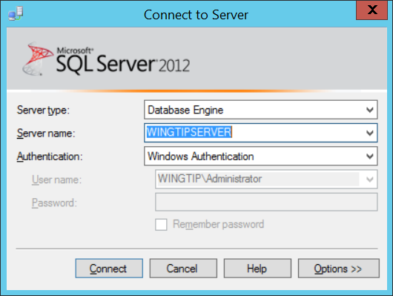

* 1. In the tree view control under **WINGTIPSERVER** node, locate and expand the **Databases** node.

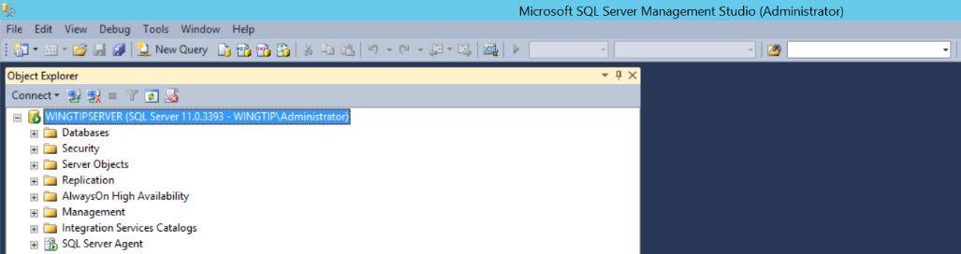

* 1. Scroll down the list of databases and find the **WingtipSales** database. You should be able to expand the Tables node and see the four tables named **Customers**, **InvoiceDetails**, **Invoices** and **Products**. You should also be able to confirm that the **WingtipSales** database currently has no views.

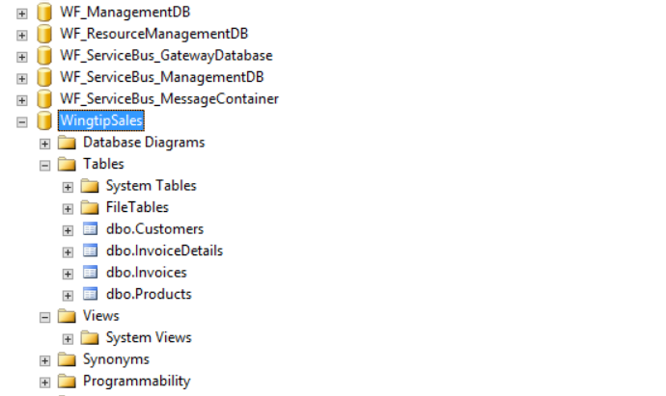

1. Create the **SalesRegions** support table.
   1. Select the top-level node in the tree view control for the **WingtipSales** database.
   2. Execute the menu command: **File > Open > File…**.
   3. In the **Open File** dialog, select the SQL script named **CreateSalesRegionsTable.sql** in the following location.

C:\Student\Modules\Cubes\Lab\CreateSalesRegionsTable.sql

* 1. Click **OK** to open the SQL script in a query window in SQL Server Management Studio.

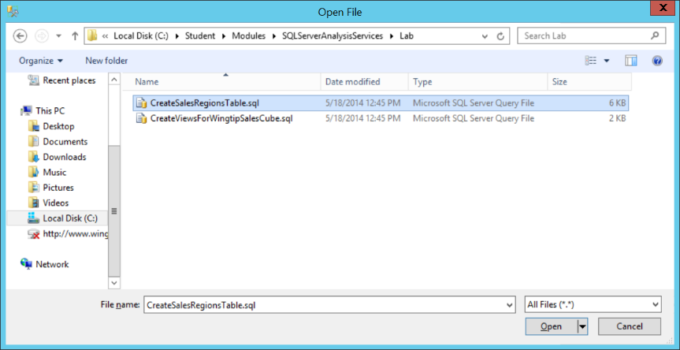

* 1. Take a moment to review the transact SQL in this script. Before executing the script, make sure that the dropdown list to the left of the **Execute** button is set to **WingtipSales** so that the script commands execute against the **WingtipSales** database.

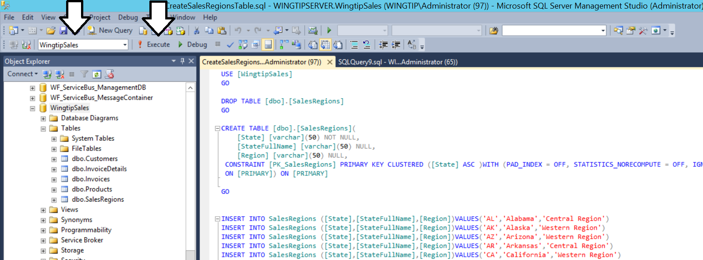

* 1. Click the **Execute** button to execute the script.
  2. After the script has executed, right-click on the **Tables** node of the **WingtipSales** database and click the **Refresh** command.
  3. After it has been refreshed, the **Tables** node should now display the **SalesRegions** table along with the other four tables that were already there.

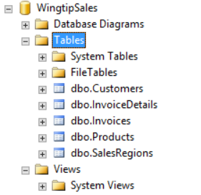

* 1. Inspect the data in the **SalesRegions** table by right-clicking its node and select **Select Top 1000 Rows**.

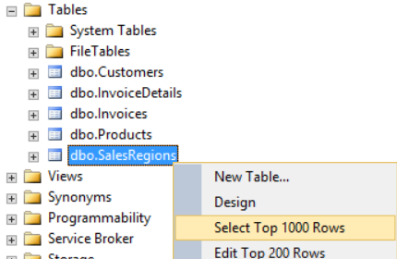

* 1. Once you have inspect the data, you can close the Query window showing the table. You can close this window without saving.

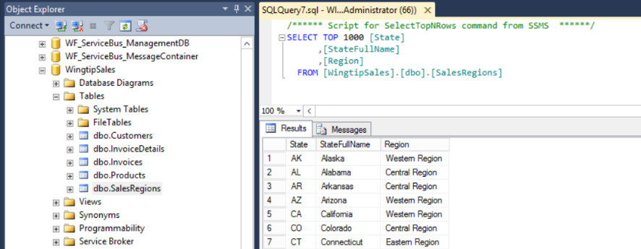

1. Create four custom views in the **WingtipSales** database to create a fact table and three dimension tables.
   1. Select the top-level node in the tree view control for the **WingtipSales** database.
   2. Execute the menu command: **File > Open > File…**.
   3. In the **Open File** dialog, select the SQL script named **CreateViewsForWingtipSalesCube.sql** in the following location.

C:\Student\Modules\Cubes\Lab\CreateViewsForWingtipSalesCube.sql

* 1. Click **OK** to open the SQL script in a query window in SQL Server Management Studio.

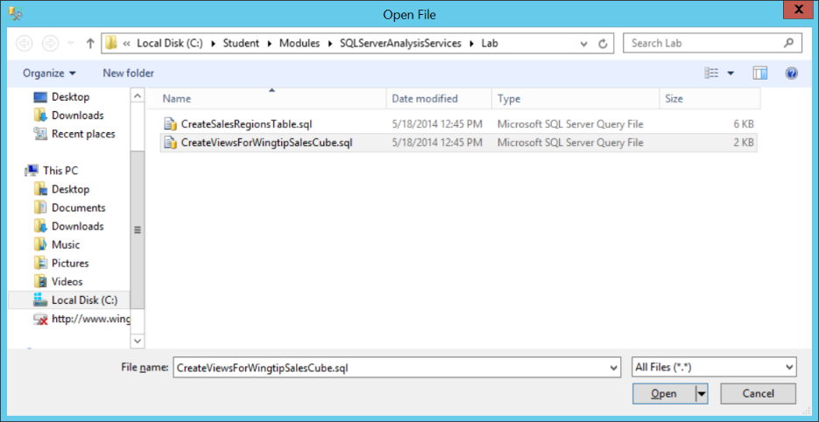

* 1. Take a moment to review the transact SQL in this script. Before executing the script, make sure that the dropdown list to the left of the **Execute** button is set to **WingtipSales** so that the script commands execute against the **WingtipSales** database.
  2. Click the **Execute** button to execute the script.
  3. After the script has executed, right-click on the **Views** node of the **WingtipSales** database and click the **Refresh** command.
  4. After it has been refreshed, the **Views** node should now display four new views named **view_CustomerDimension**, **view_ProductDimension**, **view_ProductSalesFacts** and **viewPurchaseDimension**.

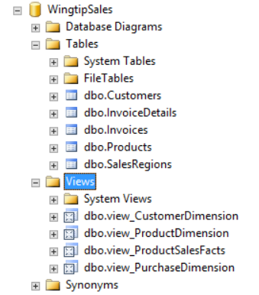

1. Inspect the data returned by **view_ProductSalesFacts**.by right-clicking it and clicking the command **Select Top 1000 Rows**.
2. Inspect the data returned by **view_CustomerDimension**.by right-clicking it and clicking the command **Select Top 1000 Rows**.
3. Inspect the data returned by **view_ProductDimension**.by right-clicking it and clicking the command **Select Top 1000 Rows**.
4. Inspect the data returned by **viewPurchaseDimension**.by right-clicking it and clicking the command **Select Top 1000 Rows**.
5. Once you have seen what the data returned from each of the 4 views looks like, close SQL Server Management Studio.

You have now completed the preparatory work in SQL Server in SQL Server which will make it much easier and more straightforward to create a multidimensional cube.

### Exercise 2: Create a new Multidimensional Project with the SQL Server Data Tools

In this exercise you will launch the SQL Server Data Tools and create a new project to create a multidimensional cube.

1. Launch the SQL Server Data Tools.
   1. Press the Windows key to display the Windows Start Page.
   2. Type SQL Server Data Tools.
   3. Locate and click the tile for the **SQL Server Data Tools**.



* 1. The SQL Server Data Tools window should open. However, the environment looks empty because there is no open project.

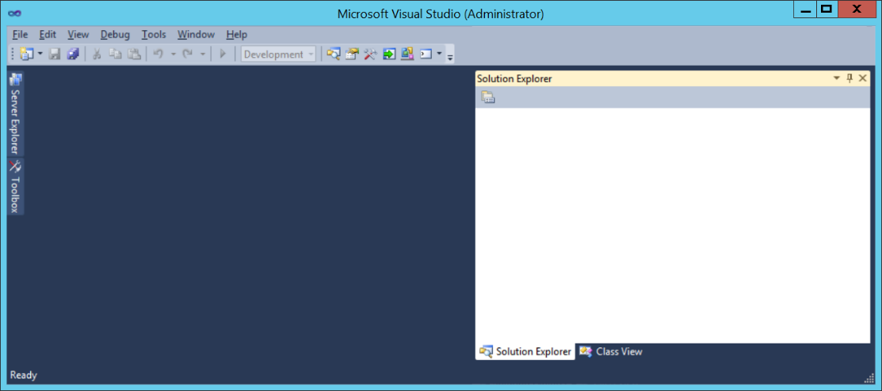

1. Create a new SQL Server Data Tools project.
   1. From the File menu, click the **New >> Project** menu command to display the **New Project** dialog.
   2. In the **New Project** dialog, select the project template **Analysis Services Multidimensional and Data Mining Project**.
   3. Give the new project a name of **WingtipSalesModelMD**.
   4. Create the new project in the folder at **C:\Student\Modules\Cubes\Lab**.
   5. Once your **New Project** dialog looks like the following screenshot, click **OK** to create the new project.

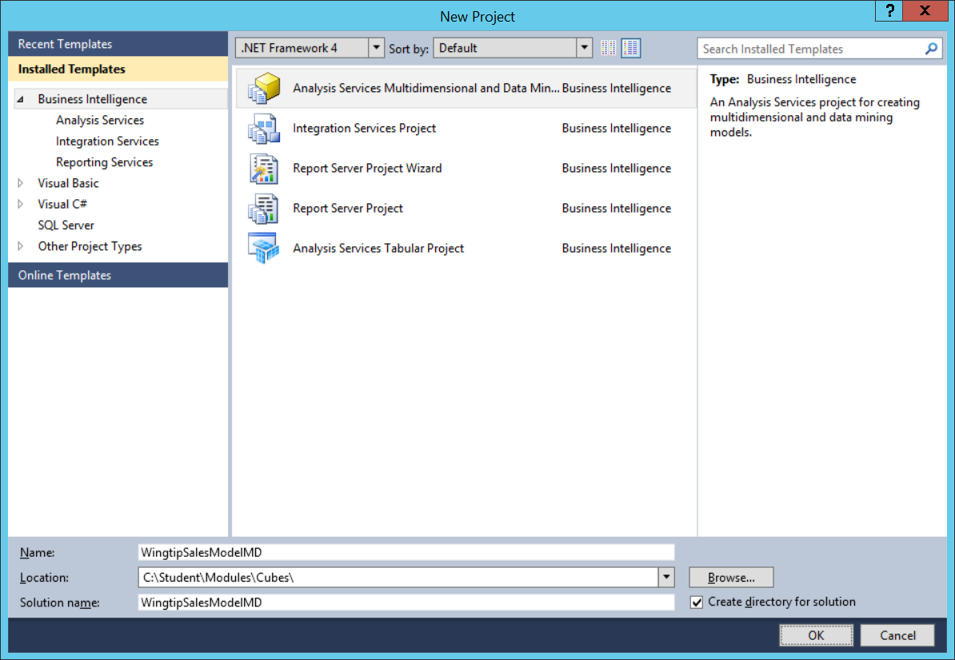

* 1. Once the project has been created, you should be able to see it as a top-level node in the Solution Explorer with empty folders below it project items such as **Data Sources** and **Data Source Views**.

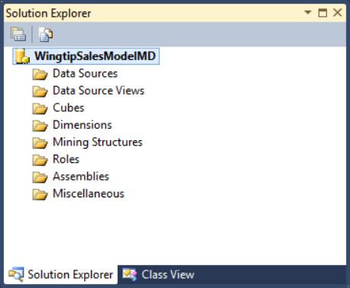

1. Create a new Data Source for the **WingtipSales** database.
   1. Locate the **Data Sources** node in the Solution Explorer.
   2. Right-click the **Data Sources** node and click **New Data Source…** to display the **Data Source Wizard** dialog.

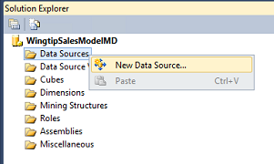

* 1. When you are prompted with the **Select how to define the connection** page in **Data Source Wizard** dialog, locate and click the **New** button to display the **Connection Manager** dialog.

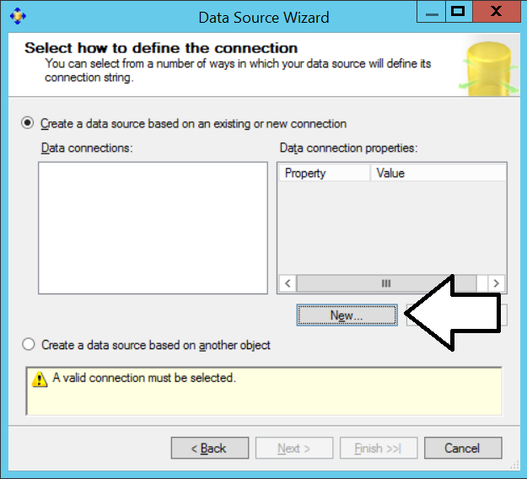

* 1. In the **Connection Manager** dialog, enter a **Server name** of **WingtipServer**.
  2. For the **Connect to a database** option, select the radio button for **Select or enter a database name** and then select the **WingtipSales** database.
  3. When the **Connection Manager** dialog looks like the following screenshot, click the **OK** button to save your changes and return back to the **Data Source Wizard** dialog.

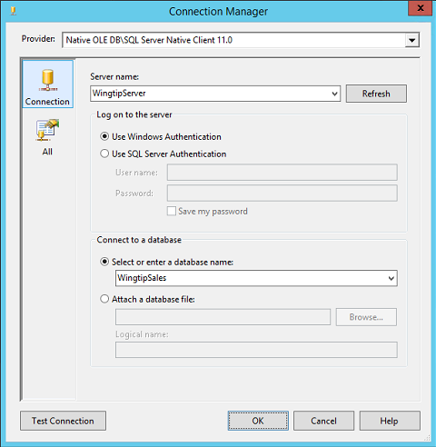

* 1. In the **Select how to define the connection** page in the **Data Source Wizard** dialog, click **Next** to continue.

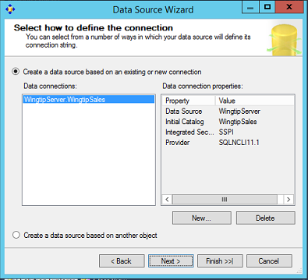

* 1. On the **Impersonation Information** page of the **Data Source Wizard** dialog, configure the project to use a specific Windows account of **WINGTIP\SP_Services** with a password of **Password1**. Once you have entered the user name and password, click the **Next** button to continue.

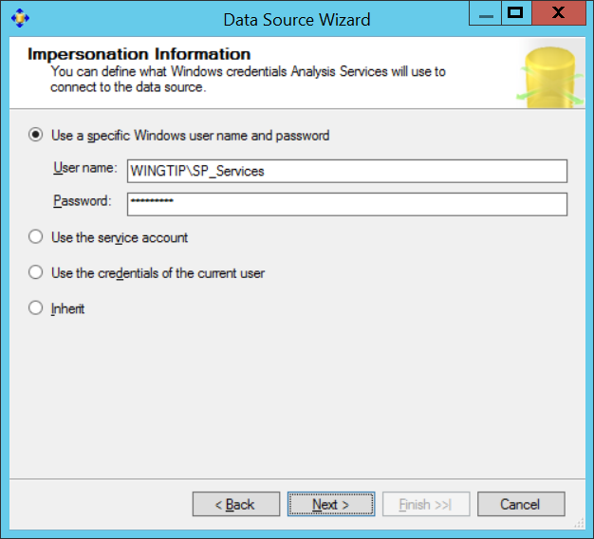

* 1. On the **Completing the Wizard** page, rename the new connection to **Wingtip Sales Database** and then click **Finish**.

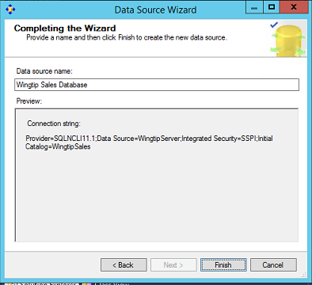

* 1. Once the **Data Source Wizard** has completed its work, you should see the new data source named **Wingtip Sales Database.ds** in the **Solution Explorer** node.

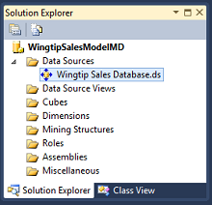

Now that you have created a data source, the next step before creating a cube is to create a data source view.

1. Create a new Data Source View.
   1. Right-click on the **Data Source Views** folder in the **Solution Explorer** and click the **New Data source View** menu command to start up the **Data Source View Wizard**.

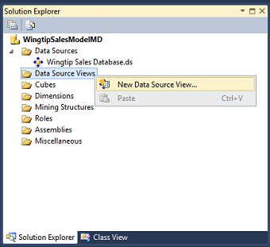

* 1. In the **Select a Data Source** page of the **Data Source View Wizard**, ensure that the data source named **Wingtip Sales Database** is selected and then click **Next** to move to the next page.

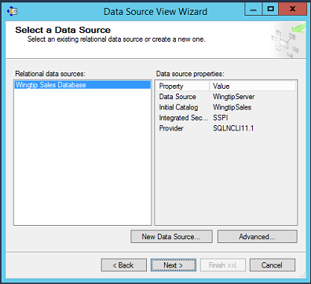

* 1. Next, you are prompted to select the tables and/or views you want to use the build your cube. Select the following views.
     1. view_CustomerDimension
     2. view_ProductDimension
     3. view_PurchaseDimension
     4. view_ProductSalesFacts
  2. Once you have the four views added into the **Included object** section as shown in the following screenshot, click **Next** to move to the next step of the **Data Source View Wizard** dialog.



* 1. On the **Completing the Wizard** page, rename the new data source view to **Wingtip Sales Data View** and then lick **Finish**.

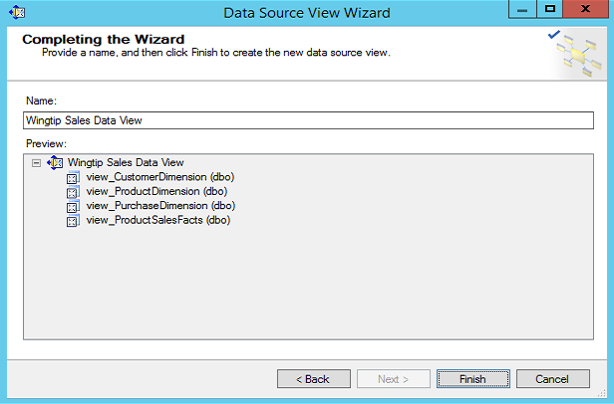

* 1. Once the **Data Source Wizard** is done, you should see the new data source view named **Wingtip Sales Data View.dsv** in the **Solution Explorer** node.



1. Inspect the new data source in Design View. You should see four new tables corresponding to the four views. However, there is some cleanup work you need to do before you begin creating a cube on top of it. Over the next few steps, you will change the table names, assign primary keys and create relationships between the tables.

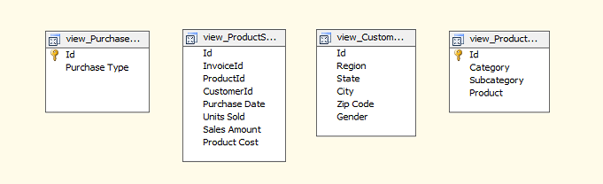

1. Rename the **view_ProductDimension** view to **Product**.
   1. Right-click on the view named **view_ProductDimension** and then select the menu command **Replace Table > With New Named Query**.

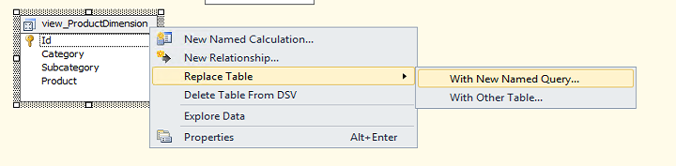

* 1. When you are prompted with the **Create Named Query** dialog, change its name from **view_ProductDimension** to **Product**. Note that you don’t have to change anything in the **Create Named Query** dialog other than the **Name** property. Click **OK** to save your changes.

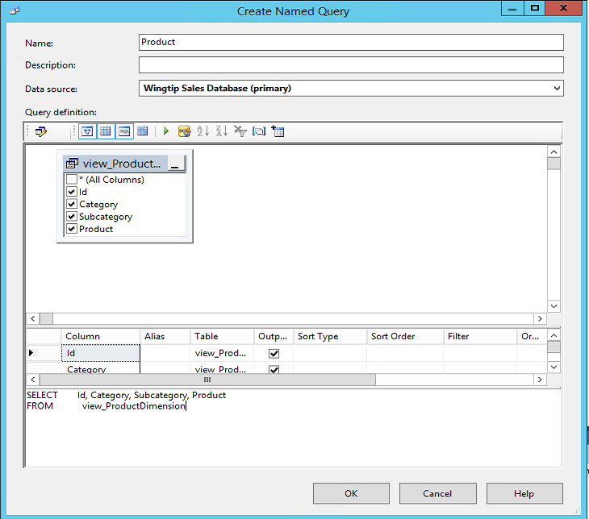

* 1. You should see that the table name is now **Product**.

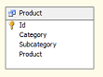

1. Follow the same set of steps to rename the **view_CustomerDimension** to **Customer**. When you are done, the table should appear in design view with the name **Customer**.

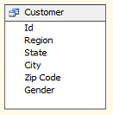

1. Follow the same set of steps to rename the **view_PurchaseDimension** to **Purchase**. When you are done, the table should appear in design view with the name **Purchase**.

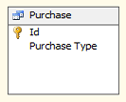

1. Follow the same set of steps to rename the **view_ProductSalesFacts** to **Product Sales**. When you are done, the table should appear in design view with the name **Product Sales**.

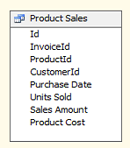

1. Now it is time to tidy of design view of the new data source view. Using your mouse, drag the tables around into a better-looking layout as the one shown in the following screenshot.

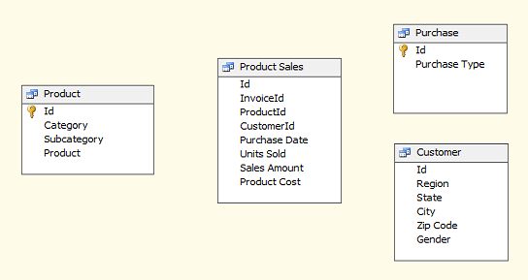

Note that the two tables **Product** and **Purchase** already have a primary key assigned that you can verify by seeing the key icon in the **Id** column. However, **Product Sales** and **Customer** do not yet have primary keys assigned. This is something you must address because each table should be configured with a primary key.

1. Make sure each table has a primary key set.
   1. Right-click on the **Id** field of the **Customers** table and select the Set Logical Primary Key command.

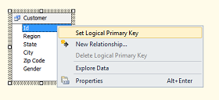

* 1. Right-click on the **Id** field of the **Product Sales** table and select the **Set Logical Primary Key** command.

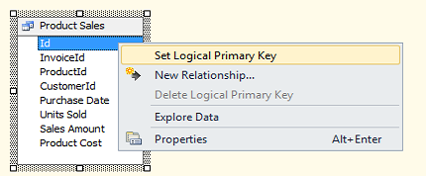

* 1. At this point, you should see that all four tables display a key icon showing that the table has a primary key.

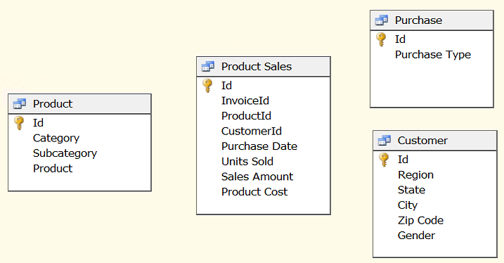

1. Create relationships between the tables in the data source view.
   1. Create a relationship between the **Product Sales** table and the **Purchase** table by dragging and dropping the **InvoiceId** column from **Product Sales** onto the **Id** column in the **Purchase** table.
   2. Create a relationship between the **Product Sales** table and the **Product** table by dragging and dropping the **ProductId** column from **Product Sales** onto the **Id** column in the **Products** table.
   3. Create a relationship between the **Product Sales** table and the **Customers** table by dragging and dropping the **InvoiceId** column from **Product Sales** onto the **Id** column in the **Purchase** table.
   4. When you are done creating the , the tables should be connected

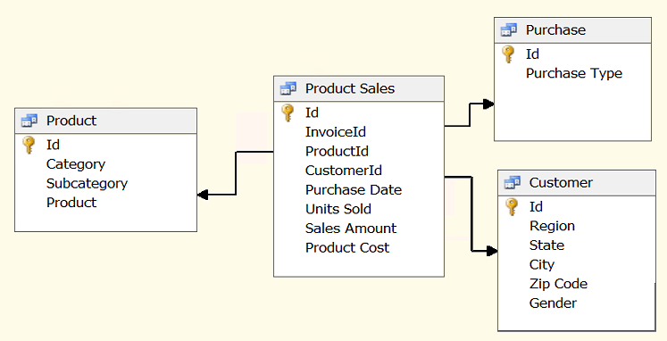

1. At this point you finished creating the data source view. Save and close the data view named **Wingtip Sales Data View.dsv**.
2. Leave the project open and move on the next exercise.

### Exercise 3: Creating a Cube to Analyze Wingtip Product Sales Data

In this exercise you will create a new cube and move through the steps of creating a measure group and dimensions to analyze product sales.

1. Create a new cube in the **WingtipSalesModelMD** project.
   1. Right-click the **Cubes** folder in the Solution Explorer and click the **New Cube…** menu command. When you do this, you will be prompted with the **Cube Wizard**.

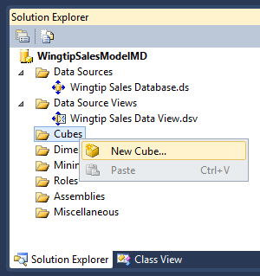

* 1. In the **Select Creation Method** page of the **Cube Wizard**, accept the default setting of **Use existing table** and click **Next**.

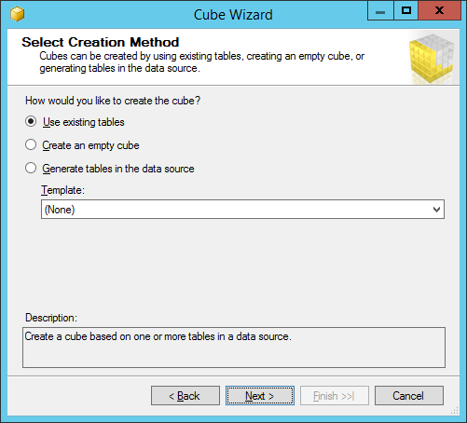

* 1. In the **Select Measure Group Tables** page of the **Cube Wizard**, select the **Product Sales** table as the one and only table you will use as a measure group table.

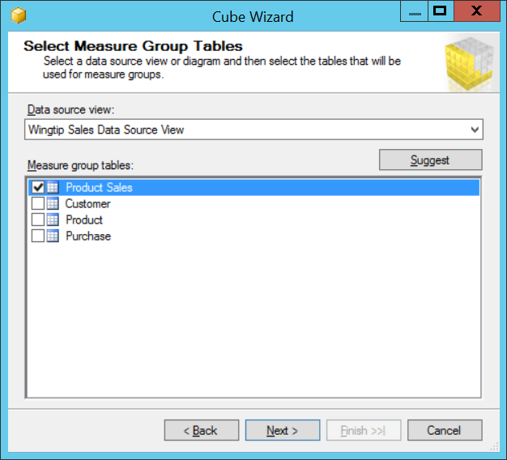

* 1. In the **Select Measures** page of the **Cube Wizard**, you will see a list of possible measures that could be created from the columns of the **Product Sales** table. Unselect the **Product Sales Count** measure. Change the name of the **Sales Amount** measure by right-clicking on it and then typing in **Sales Revenue**.

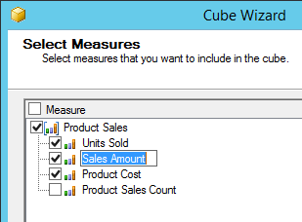

* 1. When you are done making change to the **Select Measures** page of the **Cube Wizard** dialog, it should look like the following screenshot. Click **OK** to move ahead to the **Select New Dimensions** page of the **Cube Wizard** dialog.

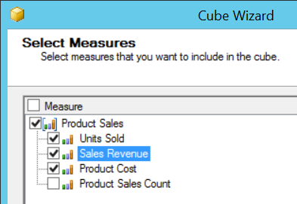

* 1. In the **Select New Dimensions** page of the **Cube Wizard**, you can see that the wizard has suggested to use the other three tables (Purchase, Product and Customer) as dimension tables. This is exactly what you want. Accept the default settings and click Next to move ahead to the **Completing the Wizard** page.

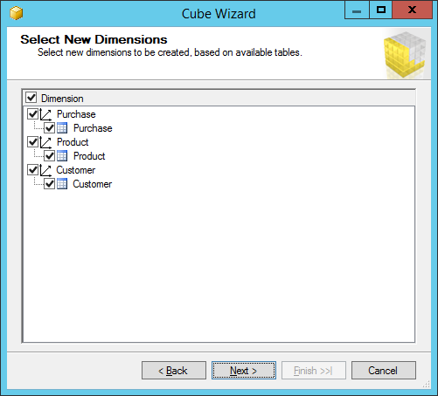

* 1. In the **Completing the Wizard** page of the **Cube Wizard**, change the Cube name to Wingtip Sales Cube and click the Finish button to create the new cube.

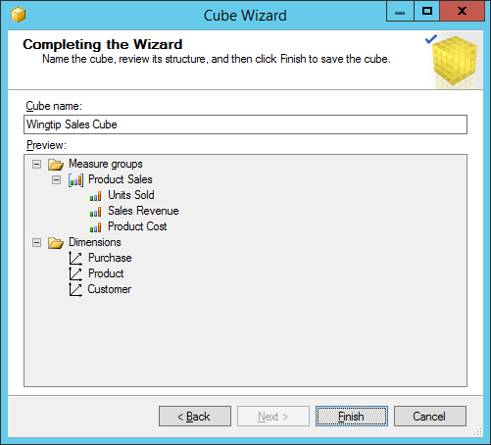

* 1. Once the **Cube Wizard** finishes its work, you should be able to see the new cube and the three new dimensions in the **Solution Explorer** on the right-hand side of the SQL Server Data Tools window.

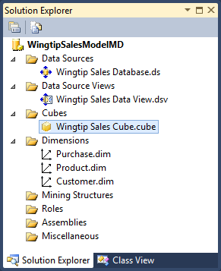

* 1. On the left-had side of the SQL Server Data Tools menu, you should be able to see the new cube opened in the Cube Designer. In the Cube Structure tab of the Cube Designer, you can see a Measures section and below that a Dimensions section. To the right there is a Data Source View section which shows the tables being used by the cube.

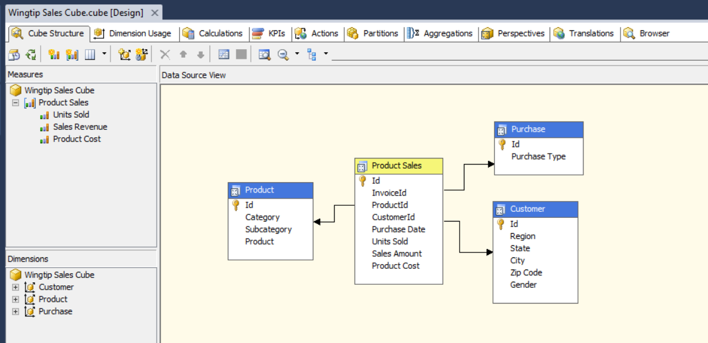

There is work that needs to be done on the cube. However, before you work on the cube itself there is also work that needs to be done on each of the three dimensions as well. As a rule of thumb, it is always best to complete work on your dimensions before you work on a cube that uses those dimensions.

1. Modify the **Purchase** dimension.
   1. Double-click on **Purchase.dim** in Solution Explorer to open the dimension in the Dimension Designer.

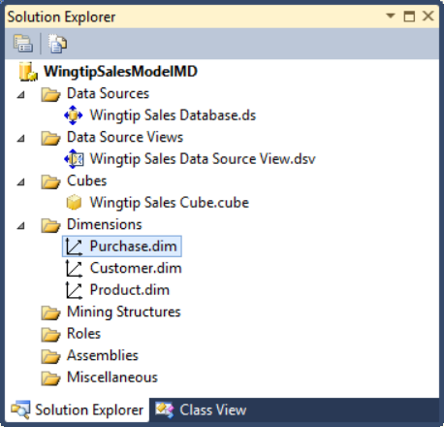

* 1. When the **Purchase** dimension opens in the Dimension Designer, it should appear as it does in the following screenshot. There are three sections in the Dimension Designer including **Attributes**, **Hierarchies** and **Data Source View**.

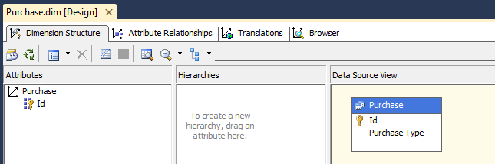

* 1. In the **Data Source View** section, you should see the **Purchase** table and a column named **Purchase Type**. Using your mouse, drag and drop the **Purchase Type** column from the **Purchase** table into the **Attributes** section to add the column as a dimension attribute. When you are done, you should be able to see **Purchase Type** in the **Attributes** section as shown in the following screenshot.

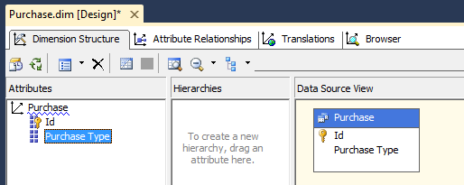

* 1. Save and close **Purchase.dim**.

1. Modify the **Product** dimension.
   1. Double-click on **Product.dim** to open this dimension in the Dimension Designer.

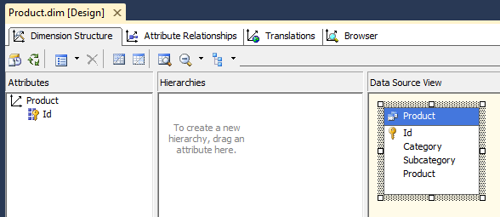

* 1. In the **Data Source View** section, you should see the **Product** table and columns named **Category**, **Subcategory** and **Product**. Using your mouse, drag and drop the threecolumns **Category**, **Subcategory** and **Product**.from the **Product** table into the **Attributes** section to add the columns as a dimension attributes. When you are done, you should be able to see **Category**, **Subcategory** and **Product** in the **Attributes** section as shown in the following screenshot.

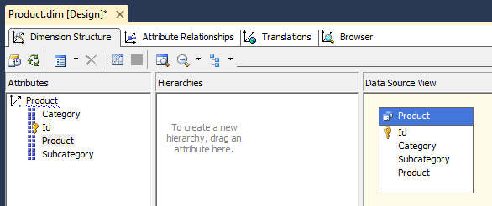

* 1. Now, it’s time to create a dimension hierarchy for product category. Begin by dragging and drop the **Category** attribute from the **Attributes** section into the **Hierarchies** section. When you do this, a new hierarchy is automatically created. However, the new hierarchy has been created with a very generic name of **Hierarchy**.

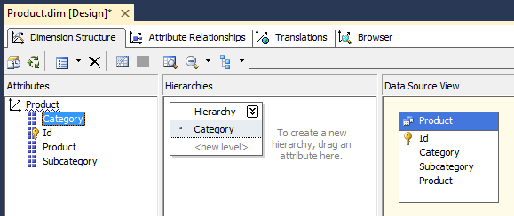

* 1. Right-click on the new hierarchy named **Hierarchy** and click the **Rename** menu command.

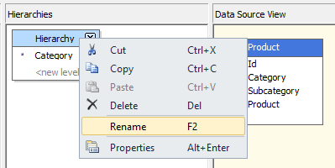

* 1. Rename the hierarchy to **Product Category**.

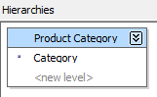

* 1. Drag and drop the **Subcategory** attribute from the **Attributes** section onto the **Product Category** hierarchy just under **Category**. Next, drag and drop the **Product** attribute from the **Attributes** section onto the **Product Category** hierarchy just under **Subcategory**. When you are done, the **Hierarchies** section of the Dimension Designer should match the screenshot.

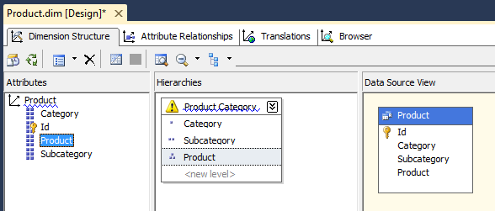

* 1. You might notice that the hierarchy name **Product Category** has a blue squiggly underline. That is there to indicate there is a problem with the hierarchy that must be fixed by modifying the dimension’s attributes.
  2. Currently, you are looking at the **Dimension Structure** tab of the Dimension Designer. Click on the **Attribute Relationships** tab to move the Dimension Designer into a different view which shows the relationships between the dimension’s attributes. This is the view that allows you to modify the attribute relationships in accordance with the hierarchy you just created.

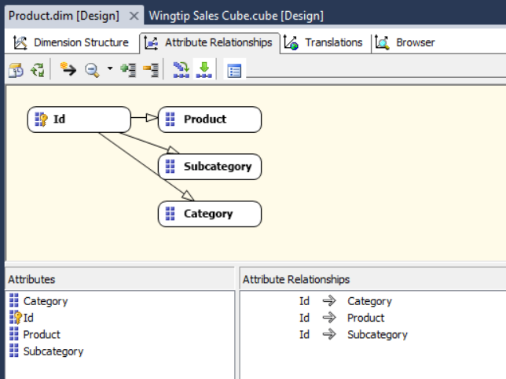

* 1. Use your mouse to drag the **Product** attribute on top of the **Subcategory** attribute. After you do this, the **Attribute Relationships** view should update to look like the view in the following screenshot.

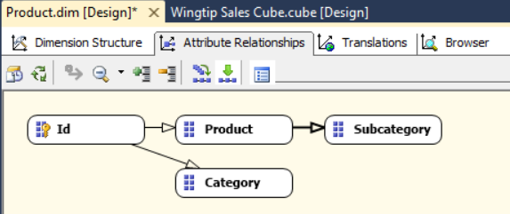

* 1. Use your mouse to drag the **Subcategory** attribute on top of the **Category** attribute. After you do this, the **Attribute Relationships** view should update to look like the view in the following screenshot.

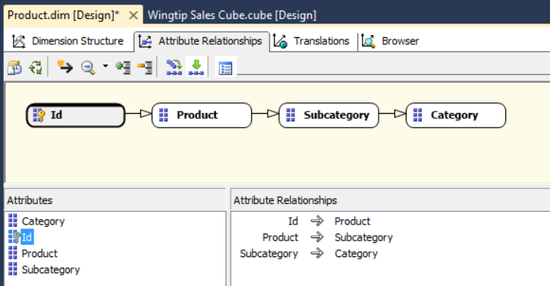

* 1. Click the **Dimension Structure** tab to move back to the original view. You should be able to verify that the blue squiggly line has been removed from the **Product Category** attribute indicating that you have fixed the problem.

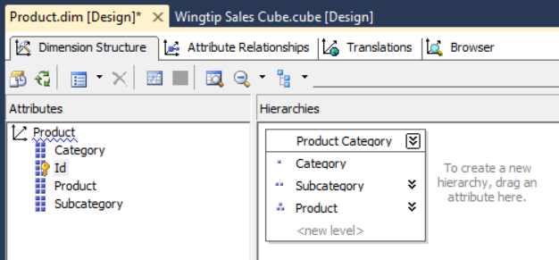

* 1. Save and close **Product.dim**.

1. Modify the **Customer** dimension.
   1. Double-click on **Customer.dim** to open the dimension in the dimension designer.

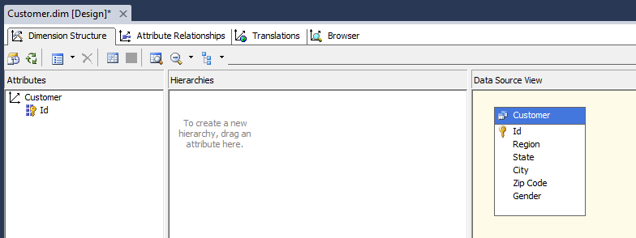

* 1. From the **Customers** table in the **Data Source View** section, drag and drop the following columns into the **Attributes** section.
     1. Region
     2. State
     3. City
     4. Zip Code
     5. Gender
  2. When you are done, the **Attributes** section should appear as the one shown in the following screenshot.

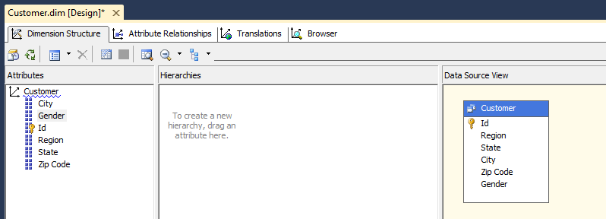

* 1. Create the **Customer Geography** hierarchy.
     1. Drag and drop the **Region** attribute from the **Attributes** section to create a new hierarchy.
     2. Rename the hierarchy from Hierarchy to **Customer Geography**.
     3. Add the State attribute into the hierarchy under Region.
     4. Add the City attribute to the hierarchy under State.
     5. Add the Zip Code attribute to the hierarchy under City.
  2. At this point, the **Customer Geography** hierarchy should appear as the one shown in the following screenshot.

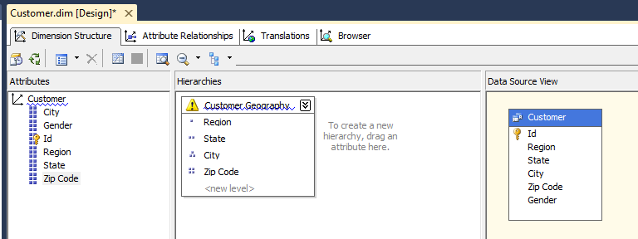

Now you must modify the attribute relationships of the Customer dimension just like you did in the Product dimension.

* 1. Click on the **Attribute Relationship** tab in the Dimension Designer. You should see that all attribute relationships are defined in terms of the **Id**.

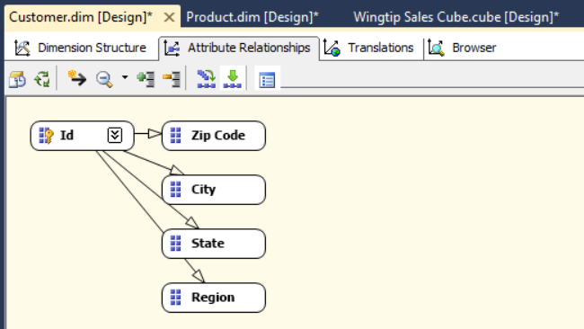

Creating the attribute relationships is a little trickier in this case than it was earlier when you created the attribute relationships between **Product**, **Subcategory** and **Category** in the **Product** dimension. The problem is that you cannot determine the State from the City because city names can be duplicated across states. Therefore, you create a relationship directly from the **Zip Code** to **State**.

* 1. Use your mouse to drag the **Zip Code** attribute on top of the **City** attribute. Next, use your mouse to drag the **Zip Code** attribute on top of the **State** attribute. Finally, use your mouse to drag the **State** attribute on top of the **Region** attribute. When you are done, the view of Attribute Relationships should match the following view.

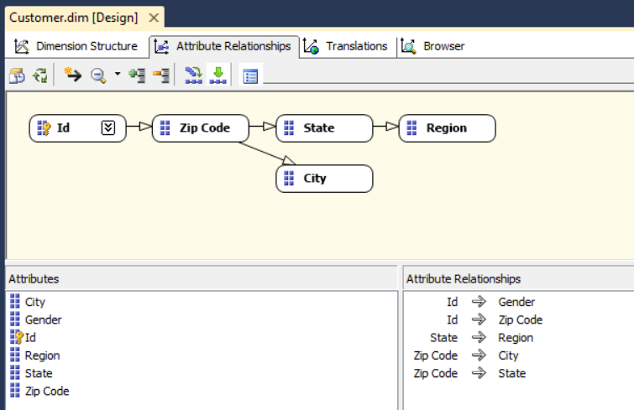

* 1. Save and close **Customer.dim**.

1. Now, return to the Cube Designer so you can inspect and work on the cube named **Wingtip Sales Cube**. Begin by examining the **Measures** section in the top left-hand corner. You should be able to see a measure group named Product Sales which contains three measures named **Units Sold**, **Sales Revenue** and **Product Cost**.

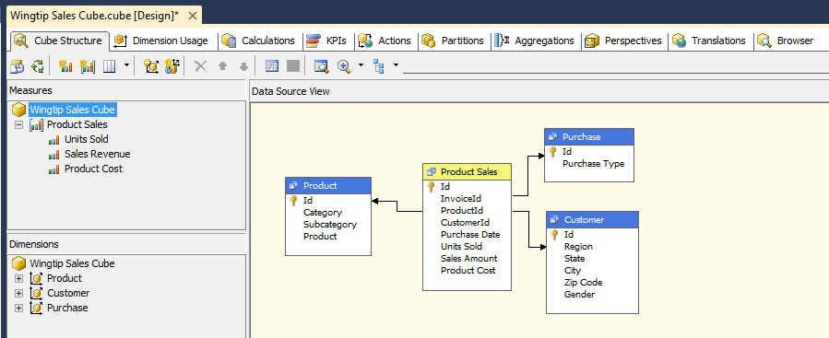

1. Use the mouse to drag the **Sales Revenue** measure to the top. Drag the **Product Cost** measure upward so it is the second measure. The measures should now appear in the following order.

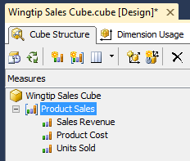

1. Change the formatting properties of each measures.
   1. Select the **Sales Revenue** measure and then locate the property sheet for the measure in the lower right-hand side of the SSQL Server Data Tools window.

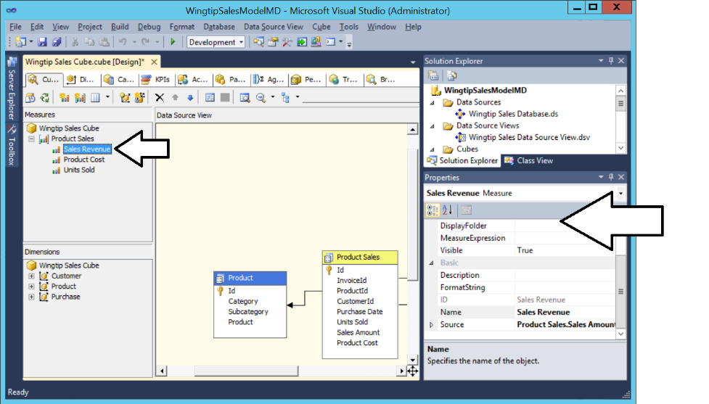

* 1. Change the **FormatString** property of the Sales Revenue measure to **Currency**.

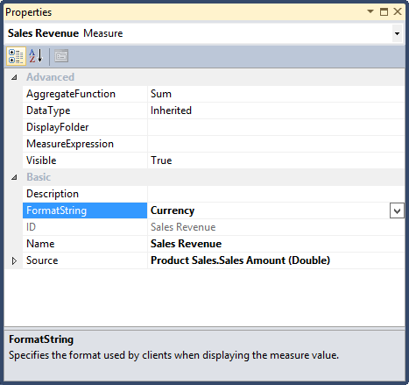

* 1. Select the measure named **Product Cost** and update its **FormatString** property to **Currency**.

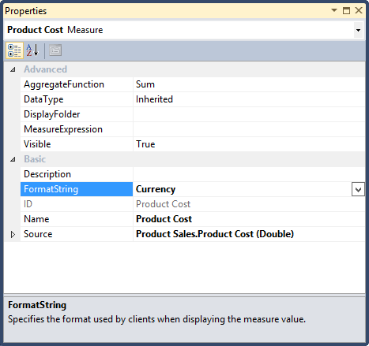

* 1. Select the measure named **Units Sold** and update its **FormatString** property by typing in a custom format code of **#,##0**.

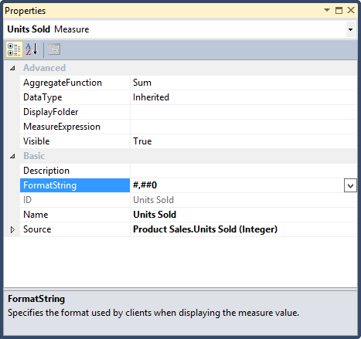

1. In the Cube Designer, click on the **Dimension Usage** tab to examine how dimensions have been related to measures. You do not need to change anything in this view, you are simply looking to see how these relationships were created by the Cube Wizard.

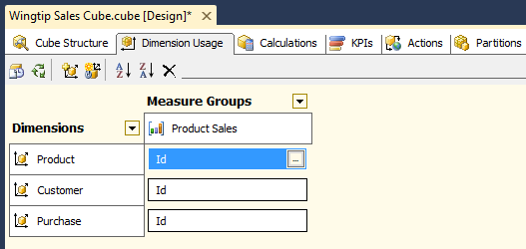

1. Create a new calculation member to calculate **Net Profit**.
   1. Navigate to the **Calculations** tab. Before you add any calculations, it will appear as the view shown in the following screenshot.

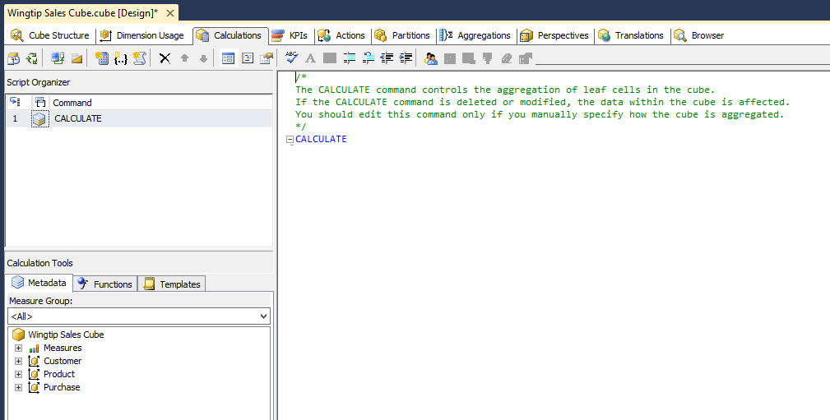

* 1. Right-click in the white area inside the Script Organizer section just under **CALCULATE** and then select the menu command **New Calculated Member**.

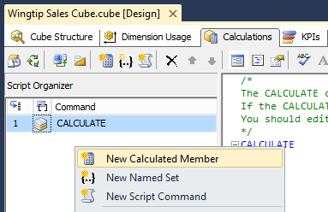

* 1. Fill out form for the new calculated member with the following information.
     1. Name: **[Net Profit]**
     2. Expression: **[Measures].[Sales Revenue] - [Measures].[Product Cost]**
     3. Format String: **"Currency"**
     4. Associated measure groups: **Product Sales**

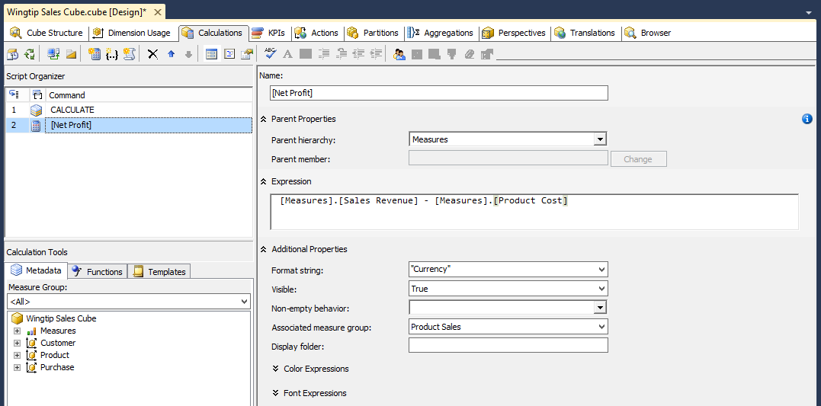

1. Create a new calculation member to calculate **Profit Margin**.
   1. Right-click in the white area inside the Script Organizer section just under **CALCULATE** and then select the menu command **New Calculated Member**.
   2. Fill out form for the new calculated member with the following information.
      1. Name: **[Profit Margin]**
      2. Expression: **[Measures].[Net Profit] / [Measures].[Sales Revenue]**
      3. Format String: **"Currency"**
      4. Associated measure groups: **Product Sales**

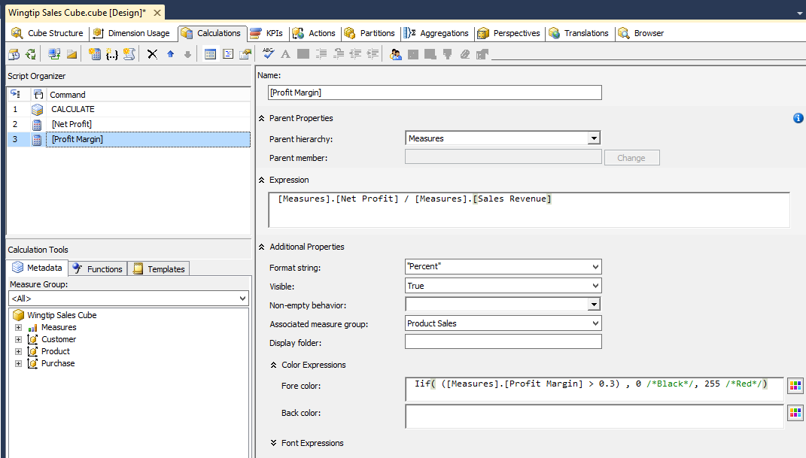

A this point, you have done enough work where you are ready to deploy the new cube so you can test using it with Microsoft Excel.

1. Deploy the cube by right-clicking the top-level project node for **WingtipSalesModelMD** in the Solution Explorer and then clicking the **Deploy** menu command.

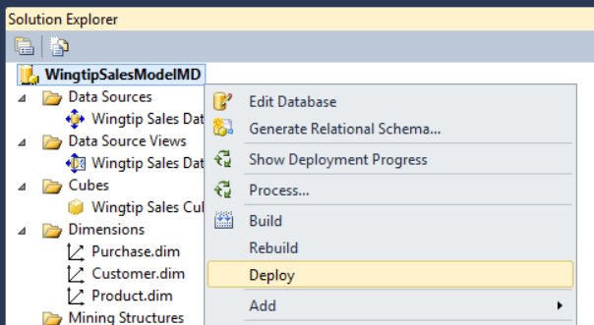

1. The **Deploy** command should process without any errors and then give you a **Deployment Completed Successfully** confirmation at the bottom of the SSDT window down below the Solution Explorer.

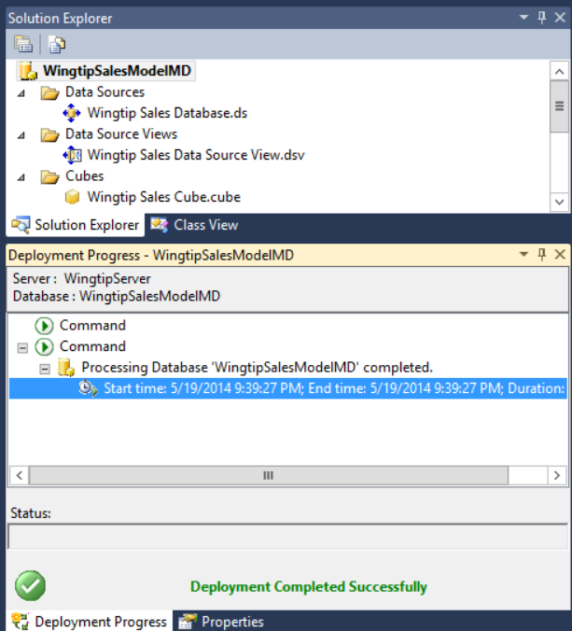

Now that the cube has been created and deployed, you can test it out using Microsoft Excel 2013.

1. Launch Microsoft Excel and create a new workbook.
2. Create a connection to the cube.
   1. Click on the **Data** tab in the ribbon.
   2. Drop down the **From Other Sources** button in the ribbon.
   3. Click the **From Analysis Services** menu command to display the **Data Connection Wizard** dialog.

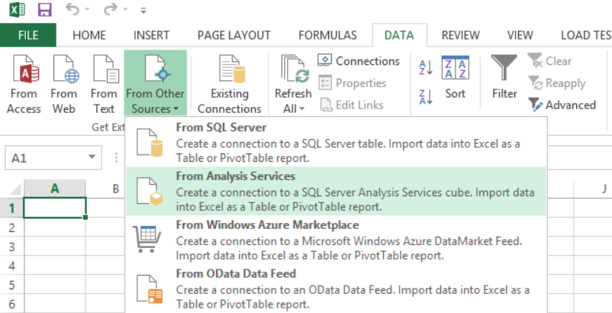

* 1. In the **Data Connection Wizard** dialog, enter a **Server name** of **WingtipServer** and click **Next**.

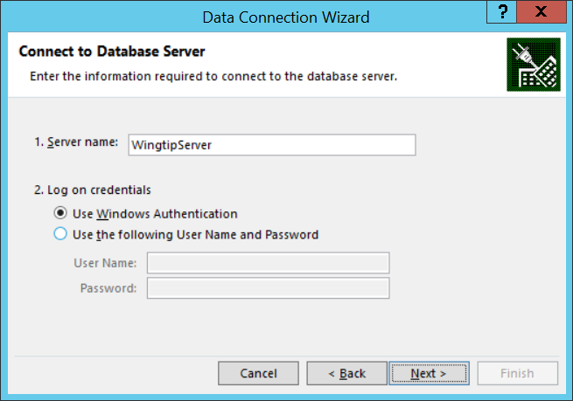

* 1. In the **Select Database and Table** page of the **Data Connection Wizard**, select the database named **WingtipSalesModelMD** and the cube named **Wingtip Sales Cube** as shown in the following screenshot and then click the **Finish** button.

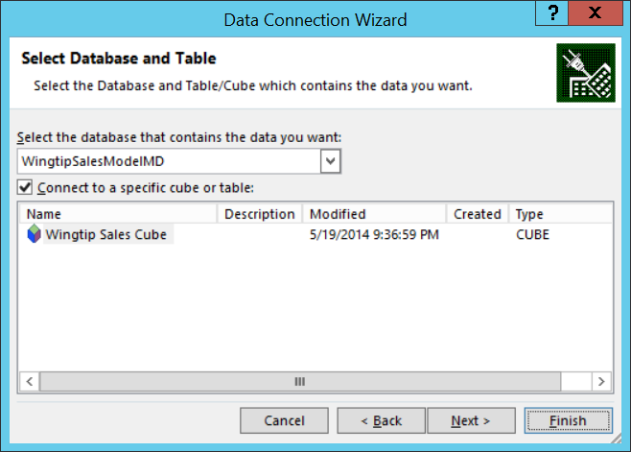

* 1. In the **Import Data** dialog, accept the default settings as shown below and then click **OK**.

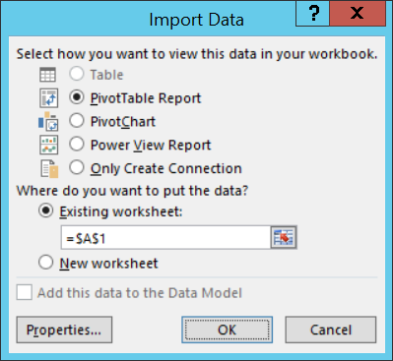

* 1. At this point you see a new pivot table and the measure and dimensions of your cube in **PivotTable Fields** section.

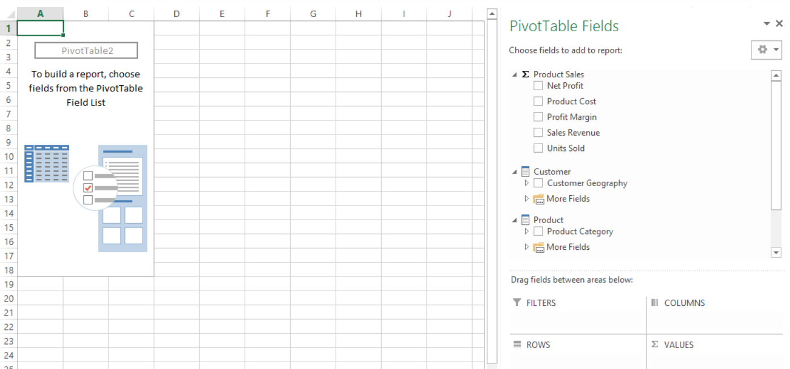

1. Add the following measures into the PivotTable.
   1. Sales Revenue
   2. Product Cost
   3. Net Profit
   4. Profit Margin

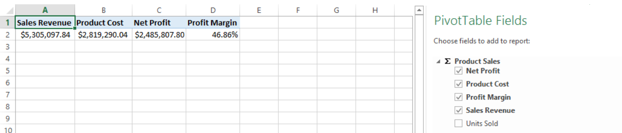

1. Add the **Product Category** hierarchy into the **ROWS** section to modify the PivotTable as shown in the following dialog. You should be able to confirm that all Profit Margin values that are less than 30% are display in red.

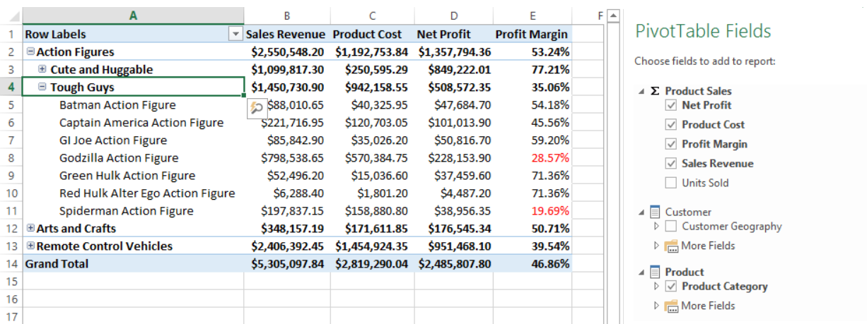

1. At this point you can leave Microsoft Excel and the PivotTable open and return back to the SQL Server Data Tools window to continue working on the development of your cube.

### Exercise 4: Adding a Server-side Time Dimension Table

In this exercise you will add a time table to the cube which will make it possible to analyze the sales data by time periods.

1. Navigate back to the SQL Server Data Tools window.
2. Make sure that the **WingtipSalesModelMD** project is still open.
3. Create a new **Time** dimension.
   1. Right-click on the **Dimensions** folder in the Solution Explorer and click **New Dimension** to display the **Dimension Wizard**.

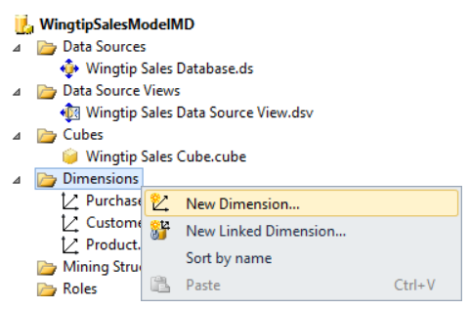

* 1. In the **Select Creation Method** page, select **Generate a time table on the server** and then click **Next**.

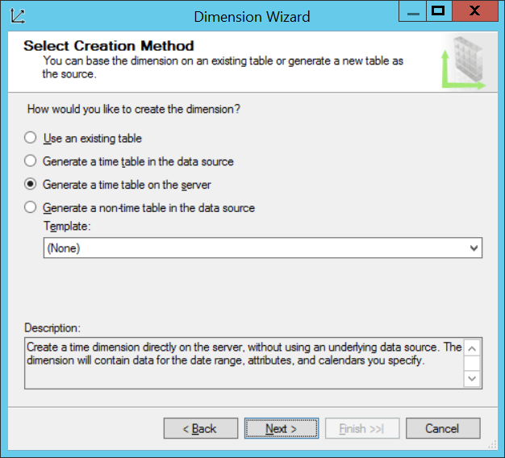

* 1. Enter the following information to Define Time Periods page.
     1. First calendar day: **1/1/2010**
     2. Last calendar day: **12/31/2013**
     3. First day of week: **Sunday**
     4. Time periods: **Year, Quarter, Month, Date**
     5. Click **Next**.

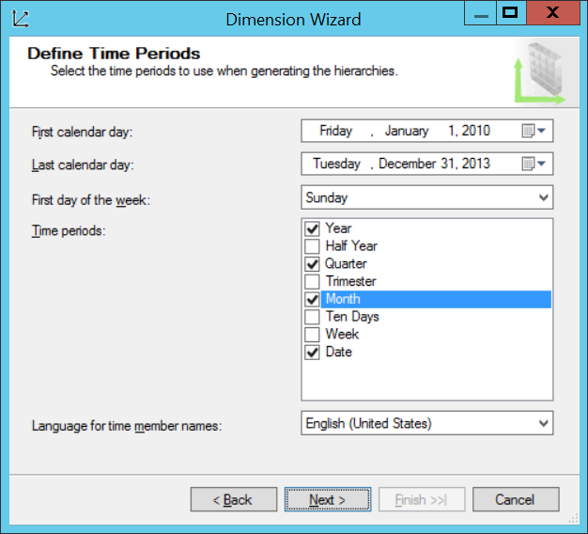

* 1. On the **Select Calendars** page, accept the default settings and clock **Next**.

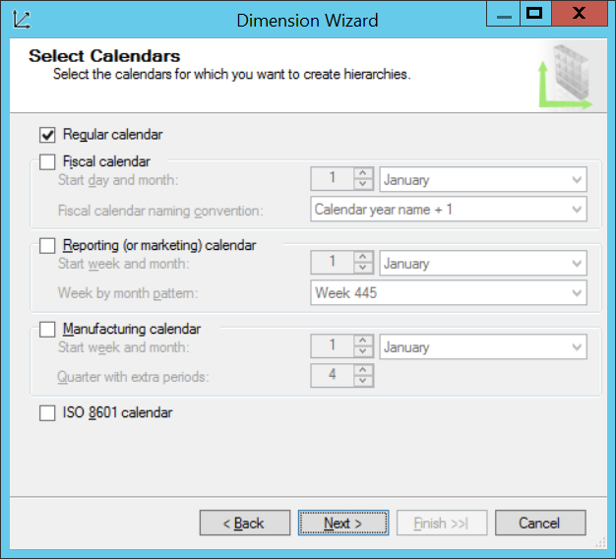

* 1. On the **Completing the Wizard** page, accept the default settings and click **Finish**.

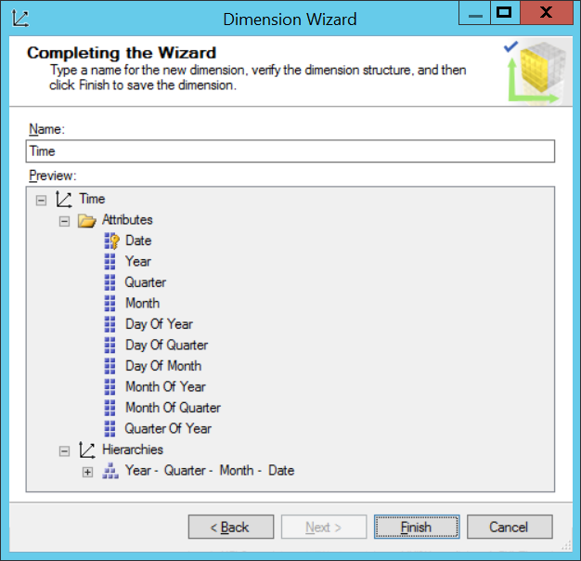

* 1. When the wizard finishes its work, it open the new **Time** dimension in the Dimension Designer.

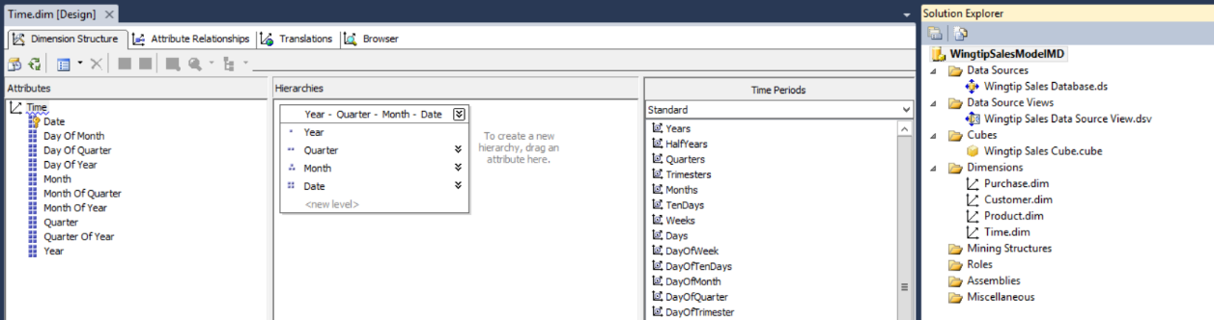

1. The wizard create a hierarchy with the name **Year – Quarter – Month – Date**. Right-click on this hierarchy and select the Rename command so that you can rename the hierarchy to **Calendar Drilldown**.

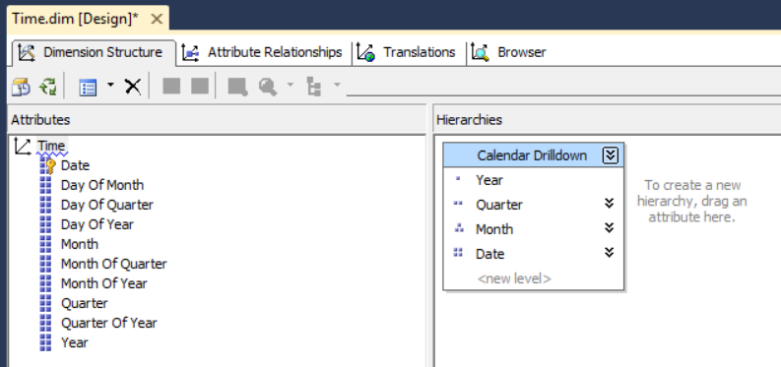

1. Click on the **Attribute Relationships** tab to inspect the relationships created by the wizard. In this step, you are just looking so there is no need to change anything.

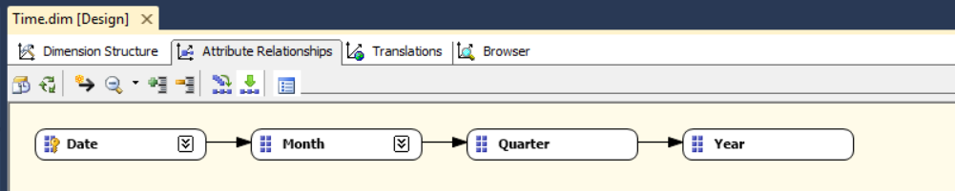

1. Save and close **Time.dim**.
2. Add the **Time** dimension to the cube.
   1. Open the cube named **Wingtip Sales Cube** in the Cube Designer.
   2. Navigate to the **Dimension Usage** tab. You should see that the cube is using three dimensions and you must add a new dimension to integrate the new time table that has been created for the **Time** dimension.

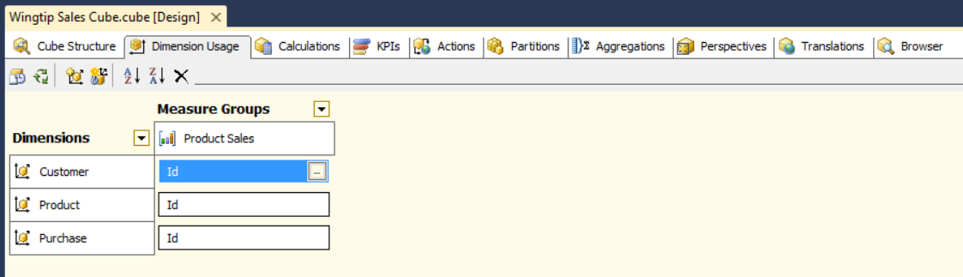

* 1. Locate the third button on the ribbon and click it to add a new dimension.

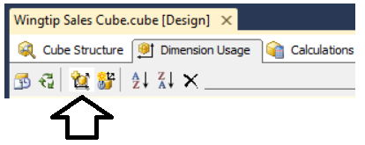

* 1. In the **Add Cube Dimension** dialog, select the **Time** dimension and click **OK**.

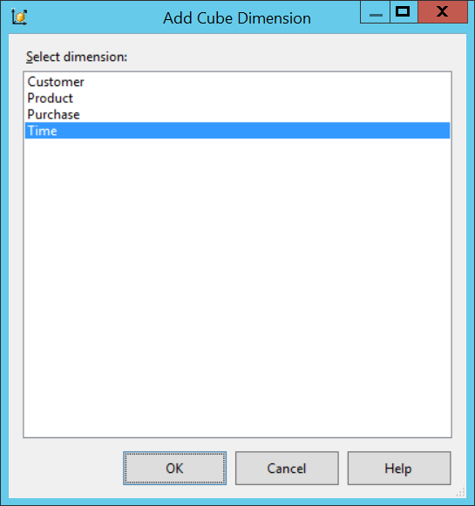

* 1. Once the **Time** dimension has been added, you should be able to see it in the **Dimension Usage** tab. However, there is currently no key associate between the dimension and the cube. Click on the button with the ellipse as shown in the following screenshot to display the **Define Relationship** page.

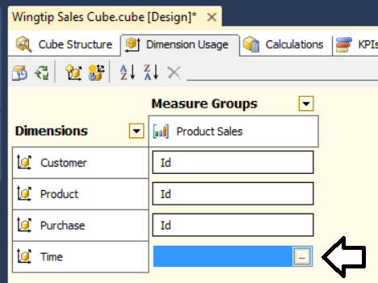

* 1. In the **Define Relationship** dialog, set the Select relationship type setting to **Regular**. Set the **Granularity** attribute to **Date**. After that select Purchase Date in the drop down list below **Measure Group Columns** as shown in the following screenshot. Click **OK** when you are done.

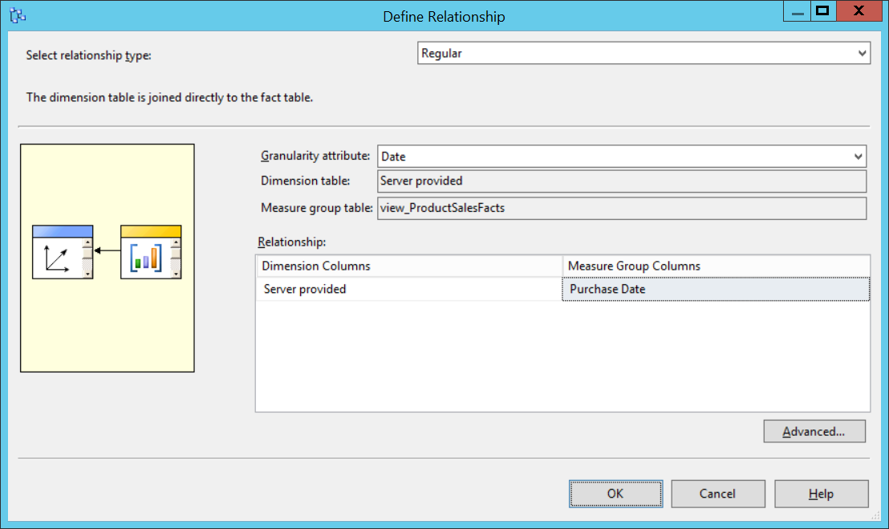

* 1. Save your changes to **Wingtip Sales Cube.cube**.

1. Deploy the cube.
   1. Deploy the cube by right-clicking the top-level project node for **WingtipSalesModelMD** in the Solution Explorer and then clicking the **Deploy** menu command.



* 1. The **Deploy** command should process without any errors and then give you a **Deployment Completed Successfully** confirmation at the bottom of the SSDT window down below the Solution Explorer.

1. Return to the Microsoft Excel application window. The workbook with the connection to your cube should still be open.
2. Click on the **Data** tab and click the **Refresh All** command.

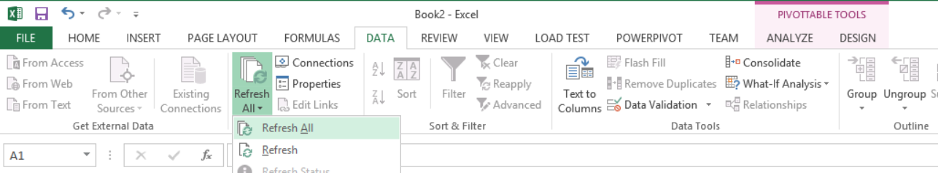

1. After you have run the **Refresh All** command, you should be able to see the most recent changes to your cube in the **PivotTable Fields** section.

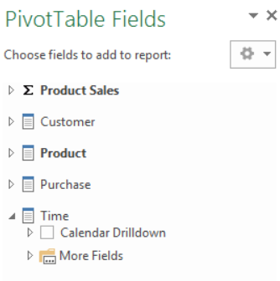

1. Modify the PivotTable by removing the **Product Category** hierarchy from the **ROWS** section and replacing with the **Calendar Drilldown** hierarchy.

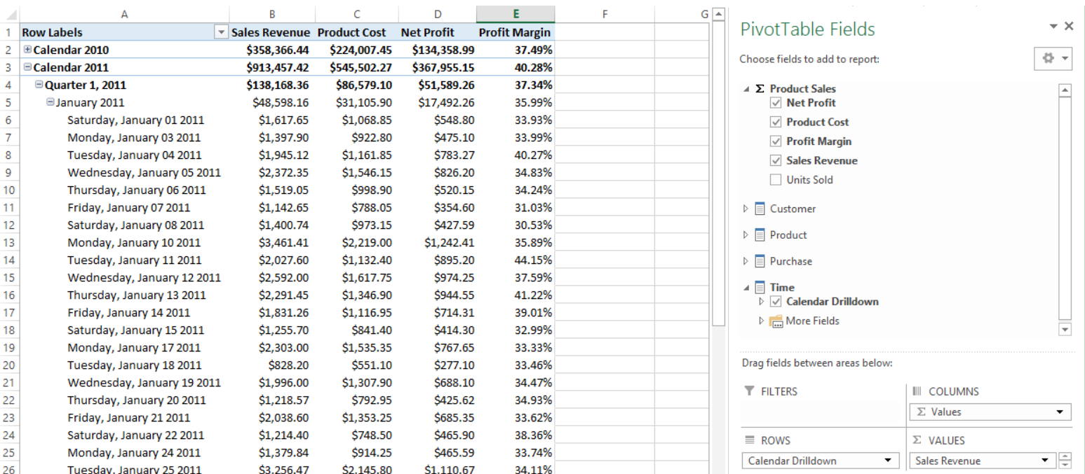

1. At this point you can leave Microsoft Excel and the PivotTable open and return back to the SQL Server Data Tools window to continue working on the development of your cube.

### Exercise 5: Adding a KPI

In this exercise you will create a KPI to monitor sales growth from month to month.

1. Navigate back to the SQL Server Data Tools window.
2. Make sure that the **WingtipSalesModelMD** project is still open.
3. Create a new calculated member **Sales Revenue PM** to calculate sales revenue for the previous month
4. Open the cube in the Cube Designer and navigate to the **Calculations** tab.
5. Create the **[Sales Revenue PM]** calculated member.
   1. Right-click in the white area inside the Script Organizer section just under **CALCULATE** and then select the menu command **New Calculated Member**.
   2. Fill out form for the new calculated member with the following information.
      1. Name: **[Sales Revenue]**
      2. Format String: **"Currency"**
      3. Associated measure groups: **Product Sales**
   3. Enter the following expression.

(

[Measures].[Sales Revenue],

PARALLELPERIOD([Time].[Calendar Drilldown].[Month], 1, [Time].[Calendar Drilldown].CURRENTMEMBER)

)

* 1. When you are done, the form should match the following screenshot.

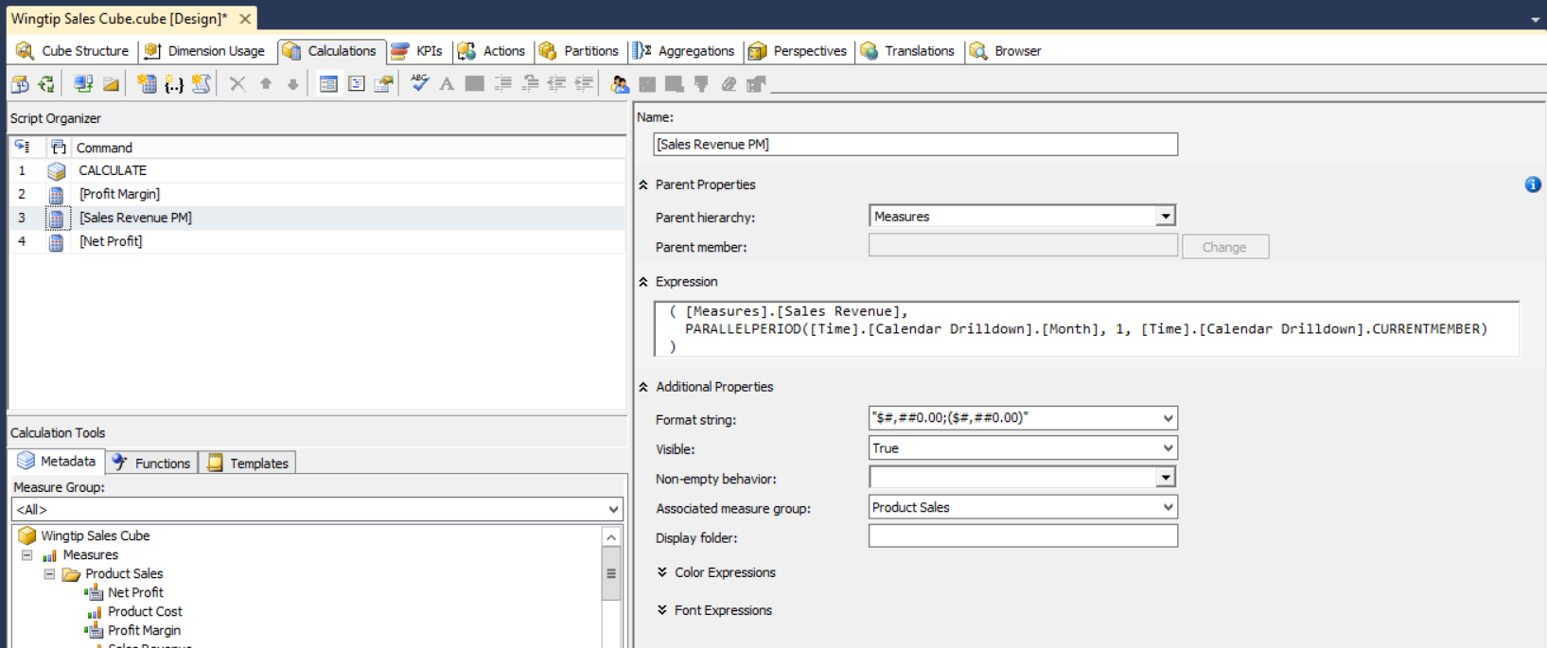

1. Create the **[Sales Growth Percent]** calculated member.
   1. Right-click in the white area inside the Script Organizer section just under **CALCULATE** and then select the menu command **New Calculated Member**.
   2. Fill out form for the new calculated member with the following information.
      1. Name: **[Sales Growth Precent]**
      2. Format String: **"Percent"**
      3. Associated measure groups: **Product Sales**
   3. Enter the following expression.

Iif([Measures].[Sales Revenue PM] = 0, NULL,

(([Measures].[Sales Revenue] - [Measures].[Sales Revenue PM]) / [Measures].[Sales Revenue PM])

)

* 1. When you are done, the form should match the following screenshot.

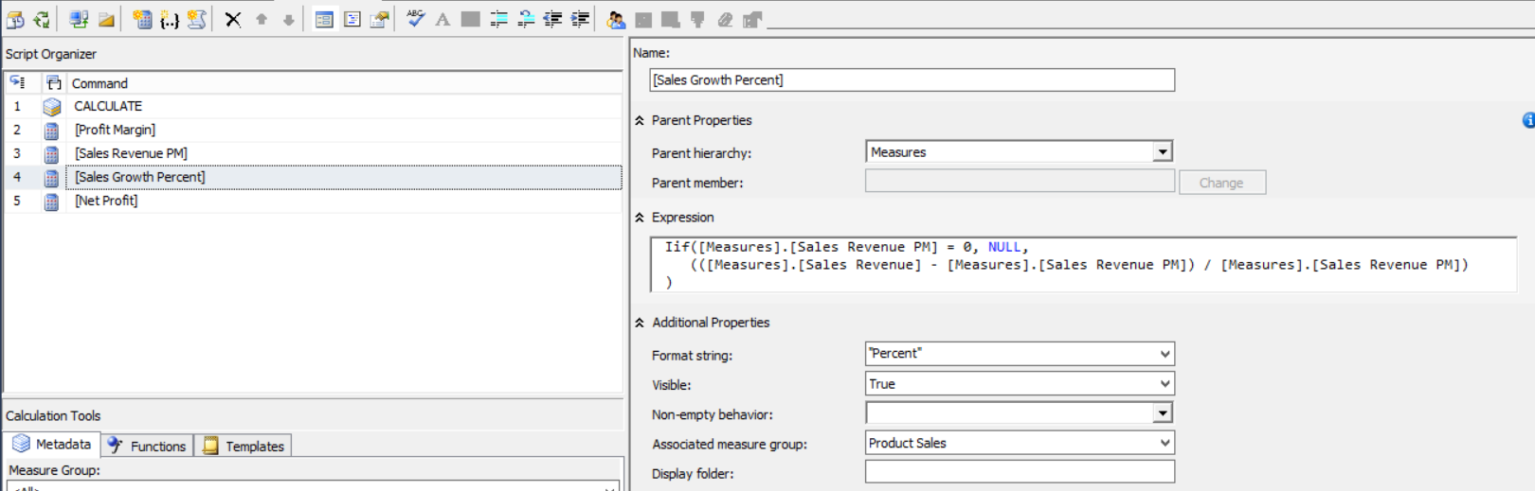

1. Create the **Sales Growth** KPI.
   1. Navigate to the **KPI** tab of the Cube Designer.

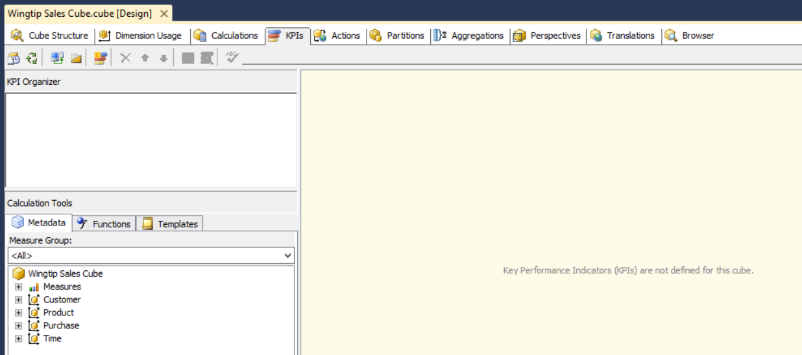

* 1. Right-click on the white space inside the **KPI Organizer** section and click **New KPI**.

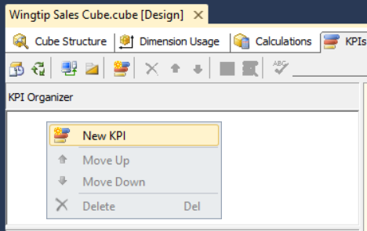

* 1. Fill out the top of the form for the new KPI with the following information.
     1. Name: **Sales Growth**
     2. Associated measure group: **Product Sales**
     3. Value Expression: **[Measures].[Sales Growth Percent]**
     4. Goal Expression: **[Measures].[Sales Growth Percent] * 1.1**

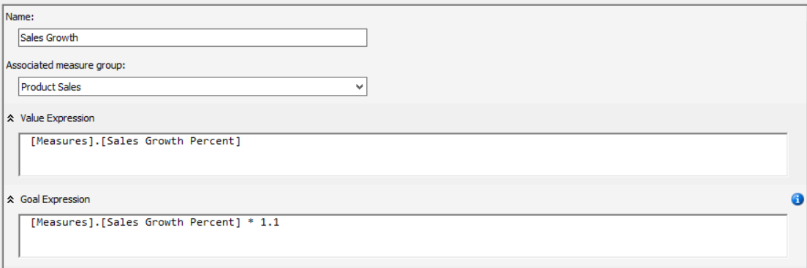

* 1. Move down to the **Status** section of the form and set the **Status indicator** to **Traffic light**.
  2. Enter the following **Status expression**.

Iif([Measures].[Sales Growth Percent] = NULL, NULL,

Case

When [Measures].[Sales Growth Percent] > 0.1 Then 1

When [Measures].[Sales Growth Percent] > 0 Then 0

Else -1

End

)

* 1. The **Status** section should match the following screenshot.

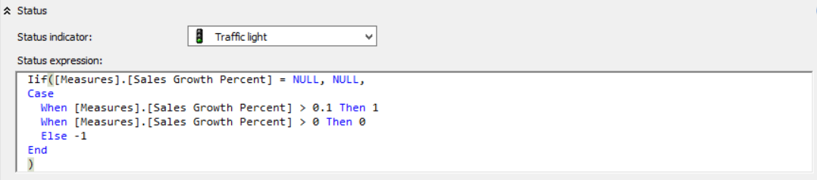

* 1. Move down to the **Trend** section of the form and set the **Status indicator** to **Status arrow**.
  2. Copy and paste the **Status expression** into the input control for the **Trend expression**.
  3. The **Status** section should match the following screenshot.

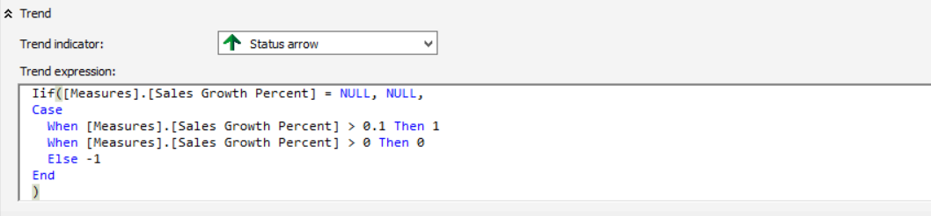

1. Deploy the cube.
   1. Deploy the cube by right-clicking the top-level project node for **WingtipSalesModelMD** in the Solution Explorer and then clicking the **Deploy** menu command.



* 1. The **Deploy** command should process without any errors and then give you a **Deployment Completed Successfully** confirmation at the bottom of the SSDT window down below the Solution Explorer.

1. Return to the Microsoft Excel application window. The workbook with the connection to your cube should still be open.
2. Click on the **Data** tab and click the **Refresh All** command.



1. You should now see the new Sales Growth KPI in the **PivotTable Fields** section. Add the Status and Trend columns of the KPI to the PivotTable as shown in the following screenshot.

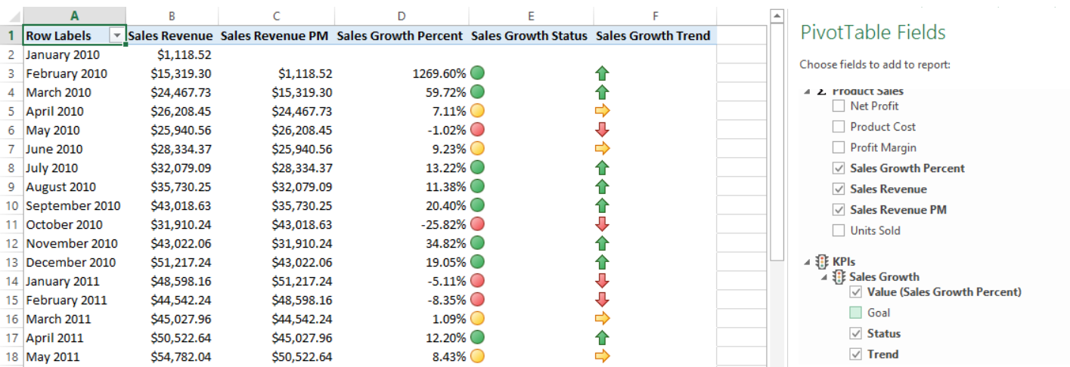

You have now built your first cube. That was quite a bit of work.